**How to search a car**

**What do I require in order to rent a car?**

Each person who desires to rent a car on our website must have a valid driver's license, passport, and a valid form of payment (generally via credit card). All of these documents must be turned in on the day the car is picked up. Please use an affiliated credit card to make your payment. In addition to your driver's license, you must present an item of identification (copies are permitted) if you intend to pay in cash.

This section explains the usage of our services for people who are renting a car on our website for the first time and for those who want to know much about how our website works.

# Step 1

Select the pick-up city from which the vehicle is to be rented, this will allow us to bring the vehicle to your door-step. After choosing the city or town you can proceed to the Next step.

Please type the pickup location (City/Town) in this text box

*­*

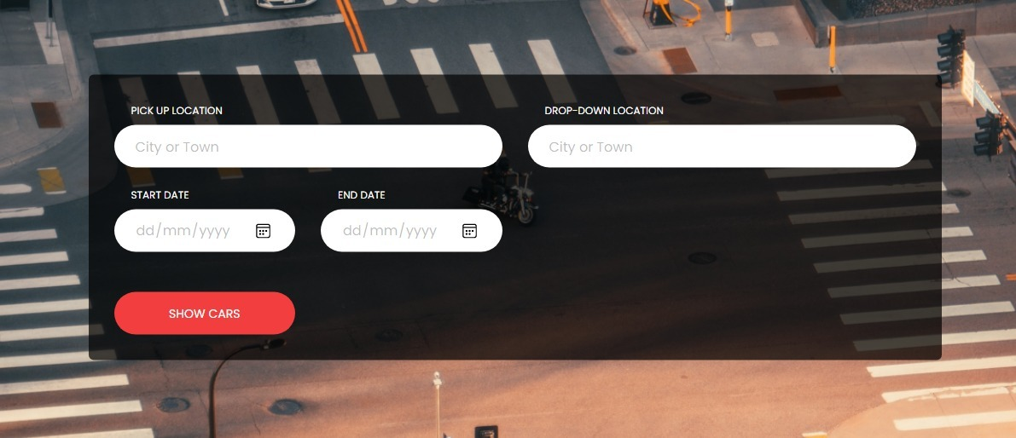

**Figure 1:** Snap shot of the first step of how to search cars

**Step 2**

Select the Drop-off city from which we will come to take the vehicle, this will allow us to come to get the vehicle at the place of your choice. After choosing the city or town you can proceed to the Next step.

*­*

Please type the Drop down location (City/Town) in this text bus

**Figure 2:** Snap shot of the second step of how to search cars

**Step 3**

Please select the starting day, month, and year you would like to start your reservation.as the date and time of rental that fit your schedule.

One-way rental services are also available (you may pick up the vehicle from one station and return it to another.

Please select the Start-up day, month and years on the drop down calendar.

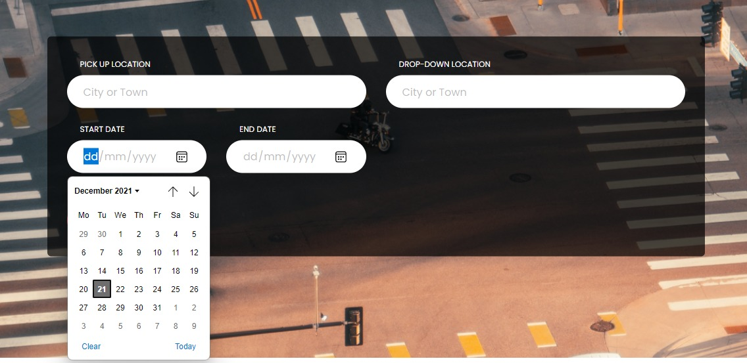

*­***Figure 3:** Snap chat of the third step of how to search cars

**Step 4**

Please select the Drop-down day, month, and year you would like to end your reservation.as the date and time of rental that fit your schedule.

One-way rental services are also available (you may pick up the vehicle from one station and return it to another.

*­*

Please select the day, month and years you will be dropping the car on the drop down calendar.

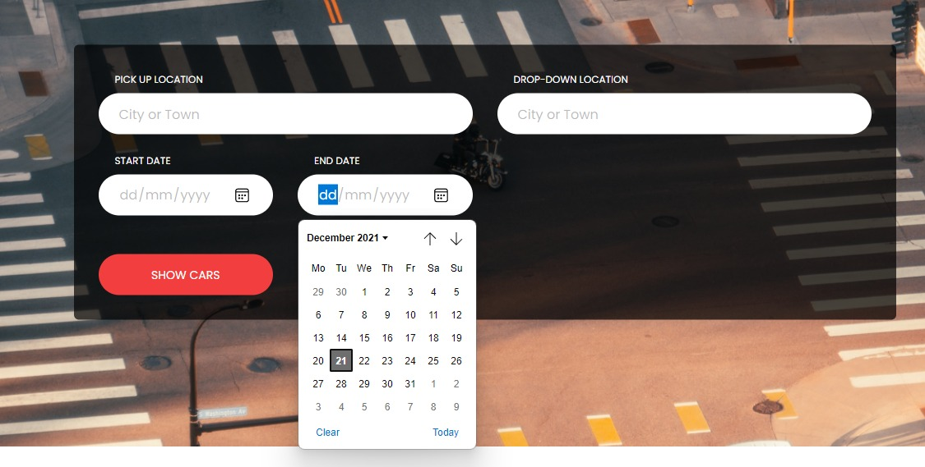

**Figure 4:** Snap chat of the forth step of how to search cars

**Step 5**

Please shows cars, this will take you to our list of vehicles available on our website, you will be able to choose vehicles base on your preference. Select vehicle and proceed to make your reservation.

**Figure 5:** Snap chat of the fifth step of how to search cars

Please click show Cars button.



**Step 6**

On this page are the list of vehicles available on the website, please Select the vehicle type and the accessories you wish to rent according to your needs

Cars are displayed, you can proceed to booking process.

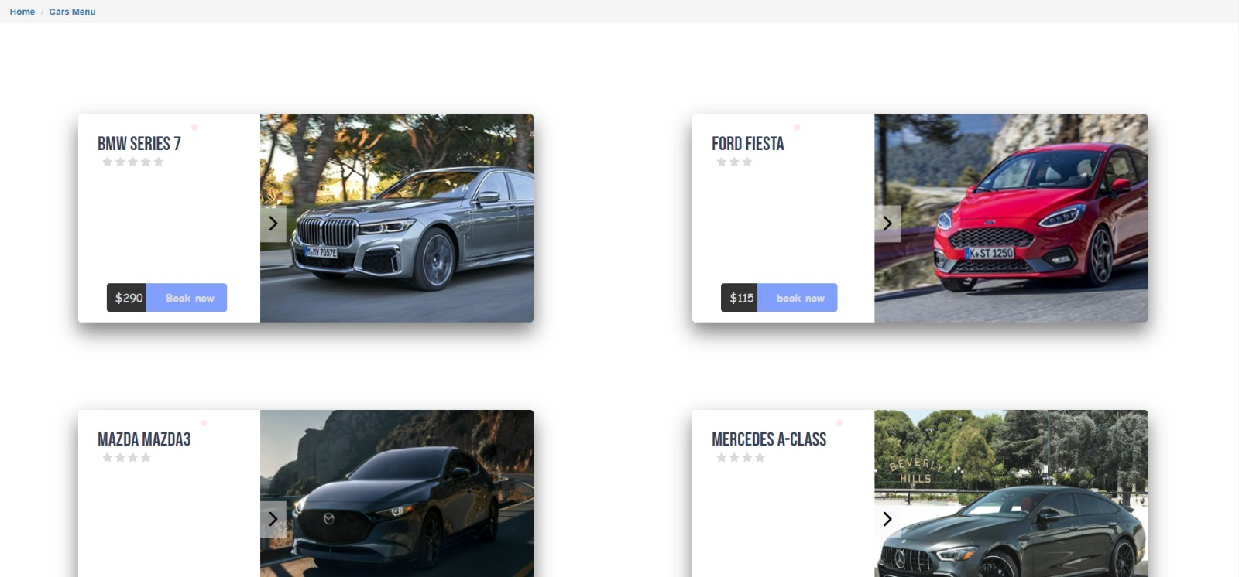

**Figure 6:** Snap chat of the sixth step of how to search cars

**How to make car reservation**

# Step 1

Select the pick-up city from which the vehicle is to be rented, this will allow us to bring the vehicle to your door-step. After choosing the city or town you can proceed to the Next step.

*­*

Please type the pickup location (City/Town) in this text box

**Figure 7:** Snap shot of the first step of how to Reservation process

**Step 2**

Select the Drop-off city from which we will come to take the vehicle, this will allow us to come to get the vehicle at the place of your choice. After choosing the city or town you can proceed to the Next step.

*­*

Please type the Drop down location (City/Town) in this text bus

**Figure 8:** Snap shot of the second step of how to Reservation process

**Step 3**

Please select the starting day, month, and year you would like to start your reservation.as the date and time of rental that fit your schedule.

One-way rental services are also available (you may pick up the vehicle from one station and return it to another.



Please select the Start-up day, month and years on the drop down calendar.

*­***Figure 9:** Snap shot of the Third step of how to Reservation process

**Step 4**

Please select the Drop-down day, month, and year you would like to end your reservation.as the date and time of rental that fit your schedule.

One-way rental services are also available (you may pick up the vehicle from one station and return it to another.

*­*



Please select the day, month and years you will be dropping the car on the drop down calendar.

**Figure 10:** Snap shot of the forth step of how to Reservation process

**Step 5**

Please shows cars, this will take you to our list of vehicles available on our website, you will be able to choose vehicles base on your preference. Select vehicle and proceed to make your reservation.

 **Figure 11:** Snap shot of the fifth step of how to Reservation process

Please click show Cars button.

**Step 6**

On this page are the list of vehicles available on the website, please Select the vehicle type and the accessories you wish to rent according to your needs.



Cars are displayed, you can proceed to booking process.

**Figure 12:** Snap shot of the sixth step of how to Reservation process

**Step 7**

Immediately you click book now on the previous page it will show you full description of the car you are about to book.

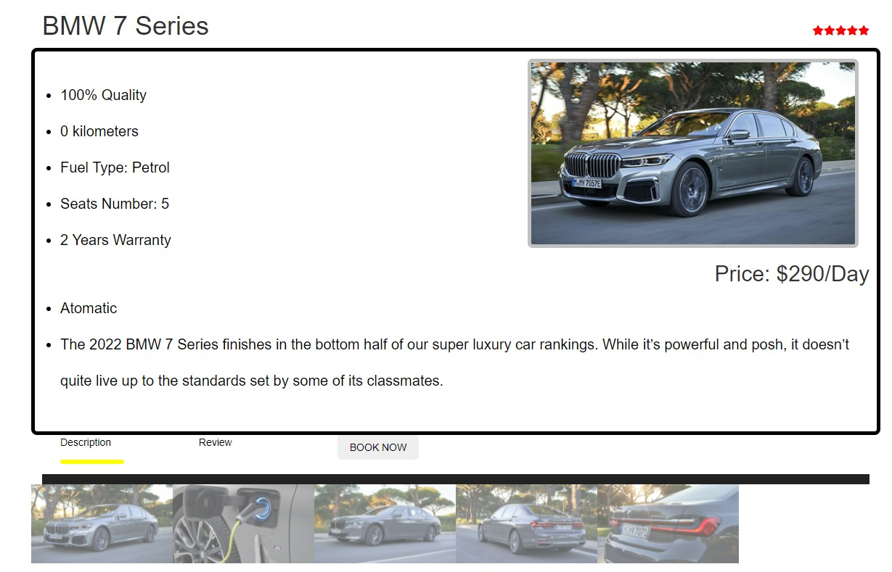

Cars description are displayed, you can proceed to entering your details.

**Figure 13:** Snap shot of the seventh step of how to Reservation process

**Step 8**

Entering Customer Information, please enter your first name and your last name in the first Text box, enter your phone number in the second text box in case we need to reach you, please upload your driver’s license, this will help know that you are eligible to drive cars, fill in your emails and write us more information in the “More enquires section of this form.

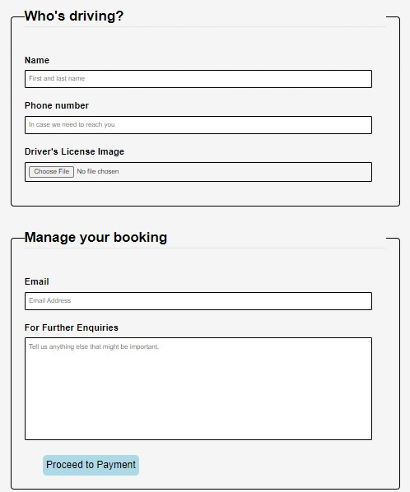

Please fill in your information and write us for further enquires.

Please fill in your information.

**Figure 14:** Snap shot of the seventh step of how to Reservation process

**Step 9**

Entering Customer Information, please enter your first name and your last name in the first Text box, enter your phone number in the second text box in case we need to reach you, please upload your driver’s license, this will help know that you are eligible to drive cars, fill in your emails and write us more information in the “More enquires section of this form.



Please click this button to make payment for your reservation.

**Figure 15:** Snap shot of the seventh step of how to Reservation process

Step 10

Payment Process

**Figure 15:** Snap shot of the seventh step of how to Reservation process

**What to Do If You're Involved in an Accident or Have Vehicle Issues**

1. Provide first help to those who have been hurt.

If there are any injured people, provide whatever first assistance you can. In this case, only move the injured victim if absolutely necessary.

2. Park the vehicle in a secure area.

To avoid further damage, move the vehicle to a safe location. Keep the car safe by employing warning triangles and flares on expressways where moving the vehicle is difficult. And call our customer care services for me +905338802409

3. Call the cops and report the accident.

Make sure to call the cops and report the accident.

4. Verify the other party's identity.

If there is a third party involved in the accident, please sure to obtain the following information:

The accident's location

Name and contact information for the other party.

5. Contact the Accident/Roadside Assistance Customer Center to report the accident.

The CAR RENTAL Accident/Roadside Assistance Customer Center is available and is open 24 hours a day, 365 days a year.

The phone number is on the Rental Guide that you received when you picked up the vehicle.

**Service to Customers**

Times CAR RENTAL offers a variety of options to ensure your safety.

Examine Yourself Every Day

We examine our vehicles every day with our own maintenance system to maintain quality and safety.



**Figure 15: Snap shot of our engineer step during daily checkups.**